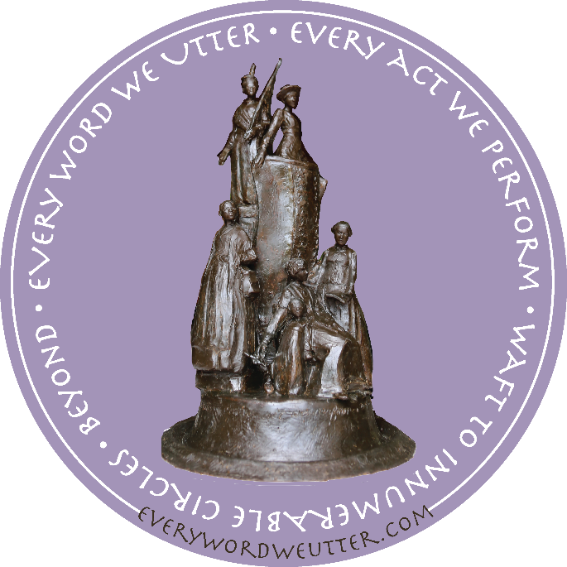
Jane DeDecker’s Every Word We Utter Reading List 2018
Wells, Ida, Edited by Duster, A. (1970) Crusade For Justice, The Autobiography of Ida B. Wells. Chicago, Illinois : The University of Chicago Press
Stanton, E.C. , Edited Stanton Blanch, H. (1922) Elizabeth Cady Stanton, in her own words. San Bernardino, CA : Big Byte Books
Gilbert, O. based on information provided by Sojourner Truth (1850, 1997) Narrative of Sojourner Truth/Sojourner Truth. Mineola, New York : Dover Publications, Inc.
Ferris, J. (1988) Walking the Road to Freedom, A Story about Sojourner Truth. Minneapolis, Minnesota : Carolhoda Books, Inc.
Perry, I. , Truth, Sojourner (1850, 2005) Narrative of Sojourner Truth. New York, N.Y. : Barnes & Noble Books
Gordon, A. D. with Bettye Collier-Thomas [et al.] (1997) African American Women and the Vote 1837-1965. Amherst, MA : The University of Massachusetts Press
Colman, P. (2011) Elizabeth Cady Stanton and Susan B. Anthony : A Friendship That Changed the World. New York, NY : Henry Holt and Company
Stanton, E.C. (1883) A Brief Biography of Susan B. Anthony. Columbia, S. C. : A.J. Cornell Publications
Bausum, Ann (2004) With Courage and Cloth: winning the fights for a woman’s right to vote. Washington, D.C. : National Geographic Society
Ward, G.C. (1999) Not For Ourselves Alone : The Story of Elizabeth Cady Stanton and Susan B. Anthony. New York, NY : Random House, Inc.
Wells, I.B., edited by Michelle Duster (1893, 2008) Ida : In Her Own Words, The Timeless Writings of Ida B. Wells from 1893. Chicago, Illinois : Benjamin Williams Publishing
Dudden, F. E. (2011) Fighting Chance : The Struggle over Women Suffrage and Black Suffrage in Reconstruction America. Oxford, NY : Oxford University Press
Kops, D. (2017) Alice Paul and the Fight for Women’s Rights. Honesdale, PA : Calkins Creek An Imprint of Highlights
Roberts Boggs, R. ( 2017) Suffragists in Washington, D.C. the 1913 Parade and the Fight for the Vote. Charleston, S. C. : The History Press
Nyad, D. (2015) Find A Way, The Inspiring Story of One Woman’s Pursuit of a Lifelong Dream. New York, N.Y. : Vintage Books
Baker Hill, J. H. (2006) Sisters: The Lives of America's Suffragists. New York, N.Y. : Hill and Wang

Weiss, E. (2018) The Woman's Hour: The Great Fight to Win the Vote. New York, N.Y. : Penguin Random House

